

# Network Diagram of the solution

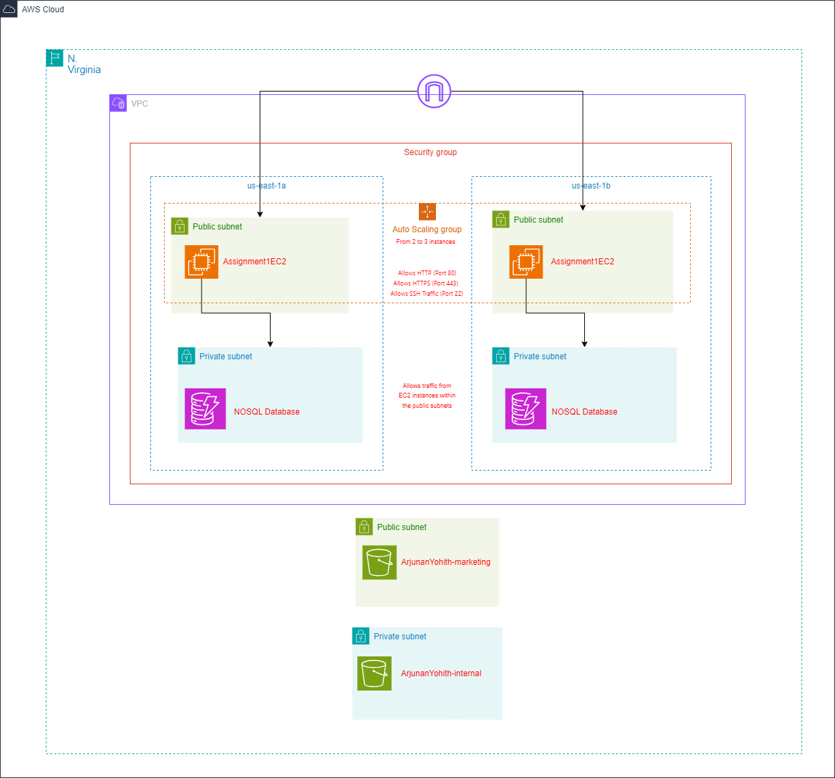

[URL of Diagram](https://viewer.diagrams.net/?tags=%7B%7D&highlight=0000ff&edit=_blank&layers=1&nav=1&title=Assignment1.drawio#R7V1bc9o4FP41zOw%2BOOO7zSMQaDvT7WaXdLv7lBFYgFpjsbZMoL9%2BJVs2tiQC7sYhNE4zxTqWJVnnfOcmifSs0Xr3Lgab1W84gGHP1INdz7rtmfTHM%2BkHo%2Bw5xbI4ZRmjIKfpB8IUfYc50SioKQpgwmk5iWAcErSpE%2Bc4iuCc1GggjvFjvdoCh0GNsAFLWBsGI0znIIRStS8oIKuc6juV2u8hWq6Kng2d31mDojInJCsQ4McKyRr3rFGMMcmv1rsRDNns1edlcuRuObAYRuScB%2B61nf79nf%2F7Z%2F9L5GtfdetffazxVrYgTPkLD75MKWEU4jTg4yb7YjI2GEUkm1BnSH9pfyO959A7I1a6MR2BIJa9OsGQS6yNOkEse3WCITZvCP0b4gArBKlUa14X%2BtcrA6S%2F1hCnJEQRHJWip1PiMgYBoiwZ4RDHlBbhiM7ecEXWIS0Z9PJxhQicbsCczeojxQ2lLXBEuPAbZlHmE89apeJNAO0r5m1knIDxeAtzhuR1whBsEjQrn4rhPI0TtIV%2FwiRvnFGpIG7Y9Xq3ZKC9AY%2BJfbOMcbrJhv%2BB9qW8%2B0AvH%2BaZYNBGSIy%2FweIle6ZF%2F02Y4A0XKAyFl9%2FCmCCKqUGIlqxtgllXgJdCuCCsRTojKFp%2BzEq3ls5nQdVFAJIVDPjryDgohJr2CncVEsfFO4jXkMR7WoXf1UrU7kuC7eWUxwPqDd3l1VYVyPd9TgRc1SzL9g9opBcckA3AaUvg%2FOtu1IGyA2UVlNvN3FTh0R%2FZk8mkVTwOBkNv6J%2FG45OW52yQ%2BnWIWrqEz76lgKertwVPV4JnmmgQJEQzgIRSBRcklhm2Nx4OqvNpHGWWKIsCa8qmVHJdEfszmWU3ZZZbZ5ZhytyybAW3bKstbvnHuTV769xyrDPY5bwou%2FoSu%2B7SWYjmjE%2FpLIKks4OdHazawYQ1h8j%2B4VB5mkG2aFjErzcYGIYrGEhKn5gTd%2Bw%2Fo9dq%2B75h%2F6CVbAzlvoBkX0ayqfJiDbstJBeRfAXKEnaTb5DMV3xqlEBWglkFaCWoZWDXqmVQU%2FQgElU0TyYacrUCnTJRRVOpIvFpQ%2FG0ITx9XBEci6wELIxvPRYaKdCzyH5EqS4g8xHMYHiHE0RQhtcZJgSvT2JqDpneqCukU8oHJJv8tRZoB4NjGiSGCU7jOcz1B9U9iUqTwMyVPhOa%2FabQNOvQtDPuCdi0%2Bwoj228LmXL25y5GW0BgZ2U7K%2Fs8VlbXB%2FZAYWXH7sSdeM9nZWVvvE0rK%2BaLLE9hZr0XNbOmHOB0ZvZKzOyobzoZpt%2BGmQ32EVjjYNYgWdQ4W2TUAerK%2BFR5wW5r6JSTRV0821naLp49mZoSM4kqS%2Bs6CkvrtIZlr7O012ppu4D2DBt1fkTr1LDpXDyiNRVp4y6i7exsF9E2tbOvIKIt1pY6O3t9draLaE8Z28bpY6P%2FqiJaS45oe6YbMt0WoG0Npe6%2FKdvkOKQvSjTOsgGtwVXhoQK9WvLPrCHGsh7b21lIz6EilSNdZ1m4A0lf5NbnQJv2RlZv6K6osaJibuop0hIQJVoCY7TISck%2BIXCtpSgvamCzCaGWU3PSFC4xcx8%2Bf8jLf2IqlDi%2F%2FjxLI5Lm1yNArVmczRwrfsoq6VPaH%2B9J6Pk9DLeQyTSrDFM%2BxEGMAG9hwIbCGs5e39THa%2FwVyWM6Sp%2Fu1zNcH43Q1LF5p8YpUnIws%2FIas11Q45YZ5rzcUGTAeAtzTszA%2FBuzp1GgceaxOvFy9ovpOPmIqhe%2Fcv5Rdmu5TWfV%2B5udUjoGYci29dIZvL%2B%2Fox%2B%2F3OGYiYmv%2F1q8AJXo%2FB3q70XJuUhJ5ExkC6pgY5jY1lWLpHZE7bRGQcAeV7p)

# Explanation of the network design

## AWS Cloud:

This represents the overall cloud environment where all my resources are located.

## Virtual Private Cloud (VPC):

This part is a logically isolated section of the AWS cloud where I can launch AWS resources in a virtual network that I define.

## Availability Zones (AZs):

From the network diagram, we can see that there are two Availability Zones in the N. Virginia region.

* us-east-1a
* us-east-1b

The use of multiple Availability Zones ensures high availability and resilience. By distributing resources across different physical locations, the architecture is protected against data center failures and other issues.

## Public Subnets:

This is the first tier of this two-tier diagram. The public subnets are designed to host resources that need to be accessible from the internet. There is a public subnet in each Availability Zone. Both public subnets contain a set of EC2 instances called ‘Assignment1EC2’ that have direct access to the internet from the internet gateway. The EC2 instances are also part of the Auto Scaling group which I will go into more detail about later.

## Private Subnets:

This is the second tier of this two-tier network diagram. The private subnets host resources that should not be directly accessible from the internet. There is a private subnet in each Availability Zone which contains a NoSQL database. The NoSQL database is placed in this for redundancy and high availability. It is used to store user information with fields such as Username, Password and Email Address.

## Auto Scaling Group:

The Auto Scaling group manages the EC2 instances in the public subsets. It ensures that the number of instances will be adjusted based on traffic demands. As shown in the diagram, there will be 2 instances at the start and will scale up to 3 when necessary.

## Security Group:

The security group controls the inbound and outbound traffic to my EC2 and Database instances.

1. For EC2 Instances

* HTTP (Port 80) allows incoming web traffic from the internet to the web servers.
* HTTPS (Port 443) allows secure web traffic from the internet to the web servers.
* SSH (Port 22) allows secure connections for server management.

1. For Database Instances

* Allows traffic from EC2 instances in the public subnets.

## S3 Buckets:

There are 2 S3 Buckets in the diagram. One of them is in a private subnet and the other is in a public subnet.

* ArjunanYohith-marketing:

This is the public S3 bucket that will store materials, in this case the lecture slides, which will be accessible to the public. This bucket is located outside the VPC boundary to represent that it is globally accessible but still within the same AWS region for performance and cost efficiency.

* ArjunanYohith-internal:

This is the private S3 bucket that will store internal materials with restricted access. It is located outside the VPC boundary but has access controls to ensure that it is not publicly accessible.

## Cost-Effectiveness:

* EC2 Instances: By using an Auto Scaling group, we can ensure that companies only pay for the instances that they need at any given time. This helps with over-provisioning and helps to reduce costs.
* S3 Storage: Using S3 for storage is cost effective as you only need to pay for what you use. The ‘ArjunanYohith-marketing’ bucket can leverage the standard storage class for frequently accessed data, while the ‘ArjunanYohith-internal’ bucket can use the Infrequent access storage class to reduce costs for data that is not accessed often.
* NoSQL Database: Using a managed NoSQL database service like DynamoDB can be cost-effective as it automatically scales and bills.

# Screenshot of the NoSQL database

I chose the Email Address as the partisan key as it will be able to uniquely identify all entries.

# Video of EC2 screen

